**Topics: Descriptive Statistics and Probability**

1. Look at the data given below. Plot the data, find the outliers and find out $μ, σ, σ^{2}$

|  |  |
| --- | --- |
| **Name of company** | **Measure X** |
| Allied Signal | 24.23% |
| Bankers Trust | 25.53% |
| General Mills | 25.41% |
| ITT Industries | 24.14% |
| J.P.Morgan & Co. | 29.62% |
| Lehman Brothers | 28.25% |
| Marriott | 25.81% |
| MCI | 24.39% |
| Merrill Lynch | 40.26% |
| Microsoft | 32.95% |
| Morgan Stanley | 91.36% |
| Sun Microsystems | 25.99% |
| Travelers | 39.42% |
| US Airways | 26.71% |
| Warner-Lambert | 35.00% |

**Using Box Plot for detecting outliers:**

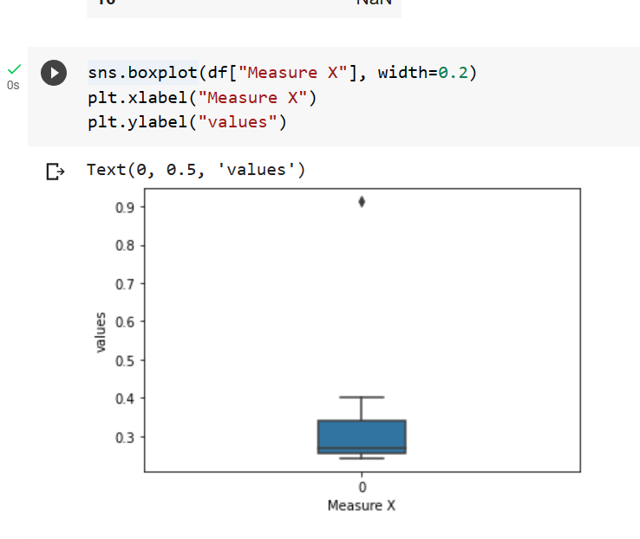

* Mean – 33.1478
* Variance – 308.988
* Standard Deviation – 17.578
* Outliers – 91.36



Answer the following three questions based on the box-plot above.

1. What is inter-quartile range of this dataset? (Please approximate the numbers) In one line, explain what this value implies.

Inter-quartile range (IQR) = 12-5=7

* Second Quartile Range is the Median Value.
* The middle 50% of the data lies between 5 and 12.

1. What can we say about the skewness of this dataset?

The dataset is right skewed, positive skewness. Most of the data point in right side.

1. If it was found that the data point with the value 25 is actually 2.5, how would the new box-plot be affected?
   1. The median will move slightly towards the left.
   2. The Q3 will move towards the left.
   3. The boxplot will no longer have any outliers.



Answer the following three questions based on the histogram above.

1. Where would the mode of this dataset lie?

The mode of this dataset lies between be 4 to 8

1. Comment on the skewness of the dataset.

The data is right skewed, the data is more concentrated towards the left and right tail is

longer.

1. Suppose that the above histogram and the box-plot in question 2 are plotted for the same dataset. Explain how these graphs complement each other in providing information about any dataset.

Both histogram and box plot is positively skewed for that data set. Histogram provides the frequency of distribution & boxplot provides quantile distribution.

1. AT&T was running commercials in 1990 aimed at luring back customers who had switched to one of the other long-distance phone service providers. One such commercial shows a businessman trying to reach Phoenix and mistakenly getting Fiji, where a half-naked native on a beach responds incomprehensibly in Polynesian. When asked about this advertisement, AT&T admitted that the portrayed incident did not actually take place but added that this was an enactment of something that “could happen.” Suppose that one in 200 long-distance telephone calls is misdirected. What is the probability that at least one in five attempted telephone calls reaches the wrong number? (Assume independence of attempts.

The probability of call being misdirected = 1/200 = 0.005

The probability of call not being misdirected = 1-0.005 = 0.995

The probability that no attempted call reaches the wrong number

=1-((0.995) ^5)

=0.0248

2% is the probability that at least one in five attempted telephone calls reaches the wrong

number.

1. Returns on a certain business venture, to the nearest $1,000, are known to follow the following probability distribution

|  |  |
| --- | --- |
| x | P(x) |
| -2,000 | 0.1 |
| -1,000 | 0.1 |
| 0 | 0.2 |
| 1000 | 0.2 |
| 2000 | 0.3 |
| 3000 | 0.1 |
|  |  |

1. What is the most likely monetary outcome of the business venture?

$2000 is the most likely monetary outcome of business venture.

1. Is the venture likely to be successful? Explain

Yes, because the probability of the venture having a return on investment is

0.6(0.2+0.3+0.1), i.e., 60% chance to be successful.

(iii) What is the long-term average earning of business ventures of this kind? Explain

(-2000*0.1) +(-1000*0.1) +(0*0.2) +(1000*0.2) +(2000*0.3) +(3000*0.1) =800

(iv) What is the good measure of the risk involved in a venture of this kind? Compute this

Measure.

Standard deviation is [1] 0.08164966

x P(x) x.P(x)

-2000 0.1 -200

-1000 0.1 -100

0 0.2 0

1000 0.2 200

2000 0.3 600

3000 0.1 300

P = 800

Hence this indicates that the venture is very risky.